**IMAGE PROCESSING SYSTEM USING MATLAB BASED ANALYTICS**

1Sneha Tulluri, III B.Tech (ECE, IARE-Hyderabad, Telangana, India)

[sneha.saipriya.tulluri@gmail.com](mailto:sneha.saipriya.tulluri@gmail.com)

2Dr.S.Chinna Venkateshwarlu, Professor-ECE

Institute of Aeronautical Engineering, Hyderabad, Telangana, India

[c.venkateswarlu@iare.ac.in](mailto:c.venkateswarlu@iare.ac.in)

**ABSTRACT:**

With the progressing software we can see the everyday advancements in image processing applications which are expanding towards the various other operations. In the real-time world we can observe that 2D and 3D image processing is available and its implementation is in a wide range. Here, in this research paper, we will be using MATLAB software analogy to produce and evaluate 3D images.

Image processing in MATLAB is very keenly heard but image simulation of videos, easy debugging, recording of the process used, numerical accuracy, and code is effortless within it. MATLAB provides various tasks for image processing, there are functions written within MATLAB thus, leading to easy implementation and open to scrutiny, making it different from Photoshop. The image processing algorithms present under MATLAB are more advanced than many editing applications. The techniques that are being used are video reversal, 3D image restoration, slow motion video, rendered volumes, geometric transformations, image segmentation, and video segmentation. Our main objective is to process 3-Dimensional(3D) images with the most recent tools and provide an empirically based method using Three Dimensional Discrete Cosine Transform (3D- DCT) with MATLAB-based analytics. The results which will be decoded can have an accurate approach to 3D image processing.

**Index terms** – MATLAB, video reversal, 3D image restoration, slow motion video, geometric transformations, image segmentation, and video segmentation or semantic segmentation, 3D-DCT

**1. INTRODUCTION:**

Image processing has developed over the years and its significance of it has progressed gradually in various fields such as medical, engineering, fingerprint detection, etc. Image processing is the technique to convert an image into digital form and the output depends on the tasks and functions that can be implemented to mold the image. [1]It describes a type of signal processing operation on an image in which the image (e.g. photo or video frame) is an input signal with output characteristics of the original/input image.[2] Image processing has been described as a mathematical operation of a computer on two-dimensional as well as three-dimensional photos and videos.

The previous explanation can be described by mathematical coordinates of x, y, and z which can have access to digital processing the brightness of the images or mirroring of the images represented by the amplitude of the functions. Further, the images can be sampled and converted into a matrix or number of matrices numbers which are approximated through digital processing. The captured image data must undergo various critical phases described in the methodology proposed and indulge in pre-processing of the image, image enhancement, display, and extraction of useful information from the image data for implementation of the functions. [3]

Image data can be in the form of a grayscale image, index image, true-color image, and binary image. A grayscale image depicts one whose pixel value is a single sample that indicates only the amount of light. This type of image consists essentially of shades of gray with variations ranging from black which represents the weakest intensity to white representing the strongest intensity. Though three-dimensional digital images can be obtained by deploying different image processing applications that can run in several technical devices (such as ultrasonic, x-ray devices, cameras, and electron microscopes), MATLAB-based image processing can be used to give the desired quality suitable for a three-dimensional image.[4]

As we know, MATLAB is a high-level programming language with features that are fundamental to both the technological and engineering disciplines with numerous algorithms that have scope for a wide range of applications for real-world applications. Seeing the rapid growth of technology being versatile scientists and engineers currently have omnipresent access to vast multimedia software and hardware devices that can run image processing applications with 2D and 3D visualizations. However, the vast applications we see in the real world need the aid of another application for its proper functioning. Thus, this study is aimed at bring forth the potentials of some of the novel features to inherent in MATLAB as an independent application tool for signal processing operations and functions with digital image processing.

**1.2. LITERATURE SURVEY**

In this case, MATLAB's signal processing application tools are designed to help scientists and engineers achieve their objectives. The following are some MATLAB-based application tools for image processing applications. Yang presented a MATLAB-based image processing system for use in medical engineering. He emphasized the importance of picture data in medical engineering as the primary means of communication, and claimed that while digital image processing in medical engineering has a high cost, it always generates effective results by reducing noise and improving image quality. Processed photos carry a lot of medical and pathological information about a particular condition in the medical engineering industry.

A MATLAB-based technique is used to perform a software simulation examination of an image recognition. The research focuses on a methodological approach that includes a MATLAB-based implementation of a software system for picture recognition analysis. Buksh et al proposed a MATLAB-based picture editing and color detection system that uses the MATLAB toolbox's built-in functions to create a variety of image processing applications. In [10], the authors stressed the use of MATLAB as a computing platform and backbone of growing visual communication, appropriate for designing and testing a variety of applications. They also advised that it be used in the teaching of digital signal processing.

According to the authors, MATLAB has a graphical user interface that makes it easier to understand the principles. It provide some insight into MATLAB-based basic image processing techniques such as edge detection, image restoration, segmentation, and denoising. Character identification and feature extraction, as well as remote sensing and computer vision, are all suggested in the authors' digital image processing application.

**2. EXISTING METHOD:**

**2.1 IMAGE PROCESSING WITH 2D DCT:**

The two-dimensional discrete cosine transform is one of the most widely used signal processing algorithms (2D-DCT). This algorithm is widely used in data compression and serves as the foundation for the widely used JPEG picture compression technology. The DCT has the ability to focus even the most virtually relevant information about an image using only a few coefficients. For image recognition tasks, such as face recognition, the DCT has extended coefficients that are significant. Image transformation from the spatial domain to the frequency domain is the foundation of the DCT empirical-based model. This method involves sampling a picture and eliminating or filtering the samples with higher frequency coefficients. Because lower frequency coefficients are more important in an image than higher frequencies, the DCT model discards the higher frequencies and quantizes the remaining frequency coefficients.

This procedure reduces the image data volume without sacrificing image quality. A C x D matrix A's 2D-DCT is represented by:

The proposed technique makes use of the DCT matrix included in the MATLAB-based image processing toolbox and works well with small square inputs such as 8 x 8 pixel picture blocks. A C x D transform matrix is denoted by:

**2.1.1. $Κ_{st}$** = ${ α}_{s}α_{t}Σ_{C-0}^{C-1}Σ_{D-0}^{D-1}A_{mn}$ cos($\frac{π\left(2c+1\right)s}{2C}$) cos($\frac{π\left(2d+1\right)t}{2D}$)

0 ≤ 𝑠 ≤ 𝐶 − 1; 0 ≤ 𝑡 ≤ 𝐷 − 1;

The values K𝑠𝑡 denote the DCT coefficients. The inverse transform of DCT given as 2D-IDCT is denoted by:

**2.1.2 $B_{cd}$** = $Σ_{s=0}^{C-1}Σ_{t-0}^{D-1}{ α}_{s}α_{t}K_{st}$ cos($\frac{π\left(2c+1\right)s}{2C}$) cos($\frac{π\left(2d+1\right)t}{2D}$)

0 ≤ 𝑠 ≤ 𝐶 − 1; 0 ≤ 𝑡 ≤ 𝐷 – 1

The values 𝛼𝑠 and 𝛼𝑡 in (1) and (2) are given by:

**2.1.3 $α_{s}= \left\{\begin{aligned}\sqrt{\frac{1}{c}} \\ \sqrt{\frac{2}{c}}\end{aligned}\right.$**  , s = 0; 1 ≤ 𝑠 ≤ 𝐶 −1

**2.1.4 $α_{s}= \left\{\begin{aligned}\sqrt{\frac{1}{D}} \\ \sqrt{\frac{2}{D}}\end{aligned}\right.$** , t = 0; 1 ≤ t ≤ D −1

The proposed technique utilizes the DCT matrix inherent in the MATLAB-based image processing toolbox and is effective for small square inputs like image blocks of 8 x 8 pixels. A transform matrix K of C x D is denoted by:

**2.1.5 $K_{st}= \left\{\begin{aligned}\sqrt{\frac{1}{C}} \\ \sqrt{\frac{2}{C}}\end{aligned}\right.$**  cos($\frac{π\left(2t+1\right)s}{2C}$); 𝑠 = 0, 1 ≤ 𝑠 ≤ 𝐶 − 1; 0 ≤ 𝑡 ≤ 𝐶 −1

Face photos are captured using a digital camera with a resolution of 1200 x 1600 pixels. And image data that has been acquired has the following characteristics:

• Tilting and rotation tolerance up to 20 degrees

• Common illumination

• Light backdrop colour

• Frontal upright position

The first step is picture acquisition, which involves using a digital camera to gather face images. Adobe Photoshop CS2 is used to pre-process the captured image data. Then, using a MATLAB-based analytic, interpolation is used to resize the pre-processed facial image from 512 × 512 pixels to 8 x 8 pixels. This design technique is utilised to calculate the 8 x 8 pixel 2D-DCT image block, in which 8 of the 64 DCT coefficients are used for masking and the remaining 56 coefficients are discarded. The next step is to do picture reconstruction by using the matrix transform method to calculate the inverse transform (i.e. 2D-IDCT) of each block. Finally, an output image is created that is identical to the original 8 by 8 pixel input image in size and form.

An example image of the preceding description is shown in Figure 2 which shows a 2D-DCT calculation of an image.

**2.2 SYSTEM DESIGN METHODOLOGY:**

Digital photography, usually a digital camera or a preloaded image from a memory source , is the most prevalent form of image capture in image processing tasks. Image processing is a technique for performing operations on a photograph, such as image enhancement or the removal of functional data from the image. Image enhancement, restoration, and compression are all common image processing techniques. Image enhancement is a technique for improving the quality of an original image by sharpening some of the details. Gray-level correction, filtering, edge cutting and sharpening, interpolation and magnification, and colour adjustment are all part of the process.

Image restoration, on the other hand, is the act of removing image noise and estimating the clean creative image. Images that are blurred or misfocused, as well as noise, can be image restored to provide the intended output image. Some techniques, including as edge detection, noise removal, and addition, are used to transform the RGB image to gray-scale, black-and-white, and binary images throughout this operation. The RGB image format is represented by a three-dimensional (3D) matrix MxNx3, where the image resolution is a matrix of MxN exhibiting the colour picture of the image represented by each RGB dimension.

A colour conversion for an image processing approach is shown in one picture, while a block diagram of an image processing technique for the suggested system is shown in the other.

Algorithm 1 is meant for color detection. MATLAB is used to achieve a great degree of transformation for a piecewise linear function using mat2gray () enhancement function [5]

**2.3 EXISTING METHOD BLOCK DIAGRAM**:

BINARY IMAGE

GRAY SHADE

BLACK AND WHITE

RGB IMAGE

INPUT IMAGE

OUTPUT IMAGE

EDGE DETECTION AND CONTRAST ADJUSTMENT

HISTOGRAM

BLUR EDGE

CROP IMAGE

SHARPNESS

GEOMETRIC TRANSFORM

MEASURE DISTANCE

EXIT

RESET IMAGE

IMAGE ARITHIMETIC

FILTERING

DEBLURRING

IMAGE ROTATION AND FLIPPING

**Figure 1: Block diagram of Existing method**

**3. PROBLEM DEFINED:**

Here in the existing method it was proposed that only image processing for 2D images was taken place which is a boon to many applications in the real world whereas the majority of image processing human beings want at the moment would be mainly 3 dimensional images. Here there are many complications to accomplish 3D image processing and to find the perfect software for image processing of it. There could be applications with only a few editing options and functions for 3D image processing and a vast variety of functions for 2D.

**3.1 PROPOSED METHOD:**

As of now we have seen many two dimensional image processing applications in a wide range it has an extensive use in JPEG and various other two dimensional images. Here in our method we have proposed the three-dimensional discrete cosine transform (3D DCT) which has been used in many 3D applications such as video coding, geometric transformations, semantic segmentation of videos and compression. Many fast algorithms have been developed for the calculation of the 1D DCT. These algorithms are then used for the calculation of the 3D DCT using the row-column approach or through mapping it to 1-D and using other transforms.

However, 3D algorithms involve fewer arithmetic operations and can be faster. Where this is a multidimensional discrete cosine transform and has the coordinates x, y and z axis. Since there a less number of applications for 3 dimensional image processing here we are using MATLAB software as there are many applications within the software that can perform functions on the image or video. Simulink can also be used by using the tools within the library and building up a model for the method of image processing.

Volume rendering is the direct rendering of data sampled in three dimensions. By modeling each voxel (volume element) as both a source and attenuator of light, volume rendering allows the visualization of interior structure and its relations to exterior forms. There are two basic approaches to volume renderings: the object space approach and the image space approach.

In the object space approach, the contributions of voxels, cells, or kernels are projected onto the image plane, whereas in the image space approach ray tracing to perform the source-attenuation integral is carried out for each pixel on the image plane. Accelerated methods have been proposed including fast algorithms that build additional data-structure prior to rendering under the assumption that there is sufficient memory to hold the data-structure. [7]

Multidimensional variants of the various DCT types follow straightforwardly from the one-dimensional definitions: they are simply a separable product (equivalently, a composition) of DCTs along each dimension.[6]

The *3-D DCT-II* is only the extension of *2-D DCT-II* in three dimensional space and mathematically can be calculated by the formula:

**3.1.1** Xk1, k2, k3 = xn1,n2,n3 cos[ (n1 + ) k1] cos[ (n2 + ) k2] cos[ (n3 + ) k3] for ki = 0,1,2,…., Ni -1

The inverse of 3-D DCT-II is 3-D DCT-III and can be computed from the formula given by:

**3.1.2** xk1, k2, k3 = xk1,k2,k3 cos[ (n1 + ) k1] cos[ (n2 + ) k2] cos[ (n3 + ) k3] for ni = 0,1,2,…., Ni -1

Here, in my project I have chosen to take up Volume visualization and Volume Semantic Segmentation of Three dimensional Models. In these models we can have a clear picture and can identify an abnormality or deformation in any organ or body part.

**3.1.3 Volume Viewer:**

The volume Viewer in MATLAB is a combination of technologies used in computer graphics and scientific visualisation to build a 2D projection from a discretely sampled 3D data set is known as volume rendering it can be used to observe medical X-rays and models of the organs of the body in different contrasts and also can be useful for viewing a collection of 2D slice images from an MRI, CT or a Micro CT scanner for a 3D data set.

I have used a CT Chest models and have observed it in Volume Viewer in MATLAB. The opacity and Image Intensity of the model can be altered by the graph on the right hand side. There are many tools in MATLAB to see the Models in certain contrasts for clear visualization and identification of any discrepancies. In Volume Viewer in the rendering editor panel, we can change the rendering style of the model which are – Volume Rendering, Maximum Intensity Rendering and Isotropic Rendering. The Colour map of the model can also be changed for visualization of the model in different contrasts. There is free movement and rendering of the three dimensional models in MATLAB which makes it convenient for study of the abnormalities and organ.

**3.1.4 Volume Semantic Segmentation:**

Volumetric Semantic Segmentation is also a very useful Tool in MATLAB as we can point out abnormalities in the organs of a body, this can widely be used in the medical field but there are many diagnostic companies that prefer using other applications other than MATLAB for their identification of enigmas in the patients organs, but I can say that MATLAB is a very functional and less code input Software which leads to accurate and essential results. Its rendering is also very niche and compact in design for easily spotting out irregularities.

In my project I performed Volumetric Semantic Segmentation on a three dimensional model where Volume image segmentation is a manual or automatic procedure that can be used to section out large portions of the volume that one considers uninteresting before rendering, the amount of calculations that have to be made by ray casting or texture blending can be significantly reduced. Here, I have identified a tumor in a human brain three dimensional model. In this tool the images of the model will be in the form of slices. There are a total of 155 slices in the 3-D brain model. In this model each and every slice shows an image of the brain in detail, all the 155 slices are continuous shots of the brain under a MRI scan. In this tool, we can paint out labels of the tumor and brain observed in the slices. Label 1 can be named as brain and Label 2 can be named as tumor, both can be drawn out accordingly with the pain tool.

Once we have identified the tumor and brain we can manually interpolate then and merge the two different labeled slice regions together and interpolate them. After interpolation the part from beginning slice to ending slice shows the tumor highlighted. With this we can identify the tumors in the brain and highlight them for further study.

**3.1 BLOCK DIAGRAM OF PROPOSED METHOD:**

INPUT IMAGE

FILTERING AND ENHANCEMENT

VOLUMETRIC VISUALISATION

OUTPUT IMAGE

REGION ANALYSIS

RENDERED VOLUMES

3D IMAGE RESTORATION

SLOW MOTION VIDEO

GEOMETRIC TRANSFORMATIONS

IMAGE SEGEMNTATION

VIDEO SEGMENTATION

SEMANTIC SEGMENTATION

EXIT

RESET IMAGE

3D IMAGE ROTATION AND FLIPPING

**Figure 2: Block Diagram of Proposed Method**

**4. SOFTWARE/HARDWARE USED:**

**4.1** MATLAB and Simulink 9.9.0

**4.2** Windows 10 laptop/computer with MATLAB

**4.3** Image processing toolbox within MATLAB

**5. EXPERIMENTAL SETUP:**

**5.1** Firstly open MATLAB and in the command prompt you can type your code. But before running your code, import an image into MATLAB by using import command and directory of the image preceding it. Which you can process with the functions in MATLAB.

**5.2** Certain functions can be accessed within the apps section in MATLAB and the process can be executed.

**5.3** Firstly image must be imported then determination of the size of the image using “*imshow(V(:,:,100),[])*”. Further we must determine the App we want to use in MATLAB by specifying the app name and project file variable name inside brackets.

Ex: “*volumeSegmentation(V)”.*

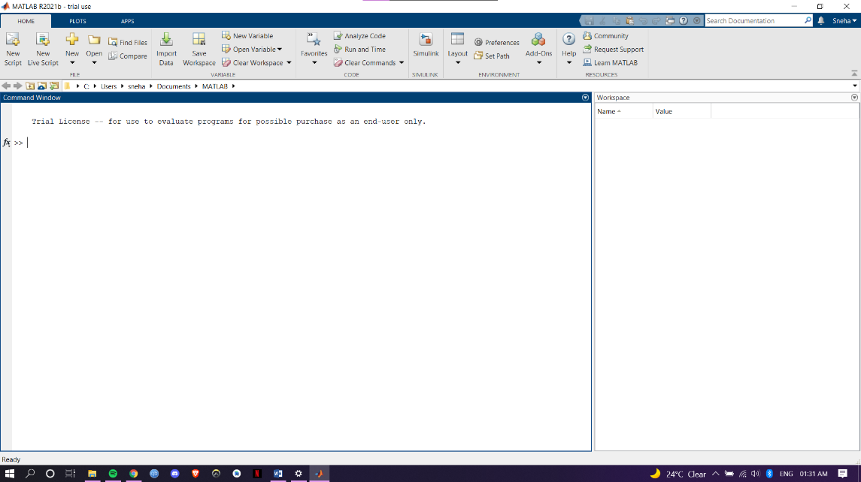

**6. RESULTS AND DISCUSSIONS:**

**6.1 Source Code of Three- Dimensional Volume Viewer:**

>>load(fullfile(toolboxdir('images'),'imdata','BrainMRILabeled','images','vol_001.mat'));

>>imshow(V(:,:,100),[])

>>volumeViewer(V)

**6.1.1 Rendered Models of Three dimensional CT Chest using Volume Viewer:**

Here, I have used a CT Chest model and have observed it in Volume Viewer in MATLAB. The opacity and Image Intensity of the model can be altered by the graph on the right hand side. There are many tools in MATLAB to see the Models in certain contrasts for clear visualization. Which I shall demonstrate what I have rendered:

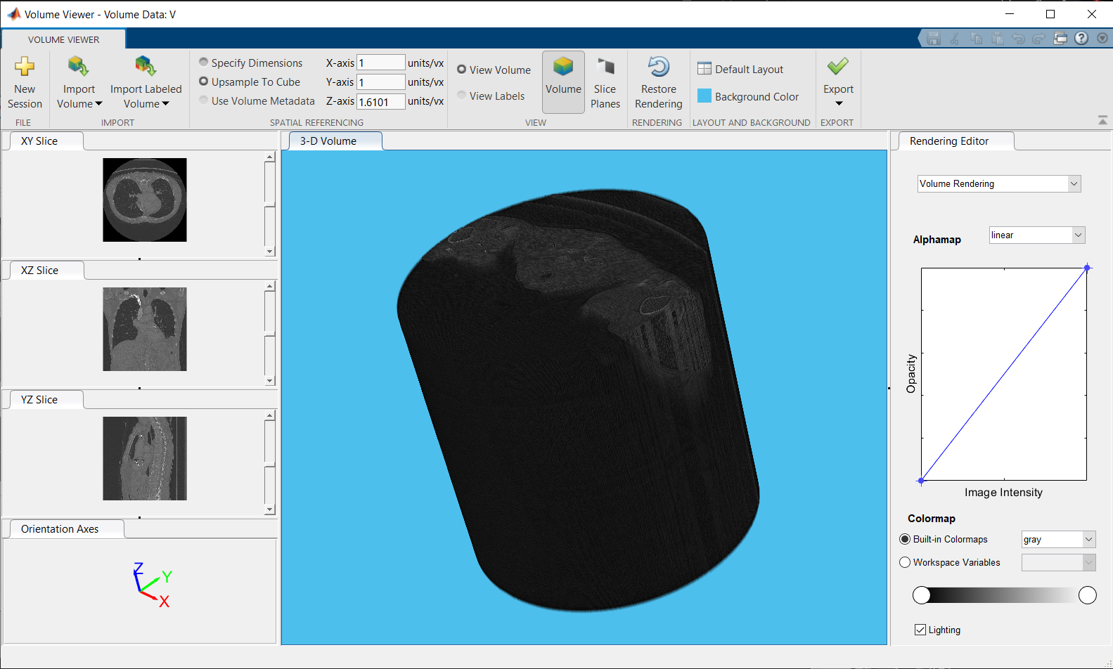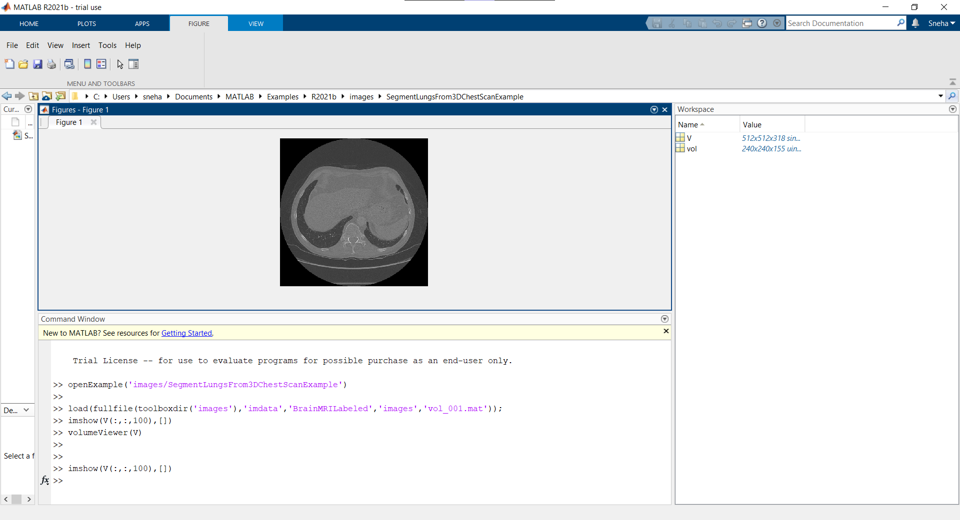**6.1.2 Figure Obtained using ‘imshow’ command:**

**6.1.3 Volume Rendering with Alpha map: Linear and Color- map: Gray:**

**6.1.4) Volume Rendering with Alpha map: Custom and Color-map: Gray:**

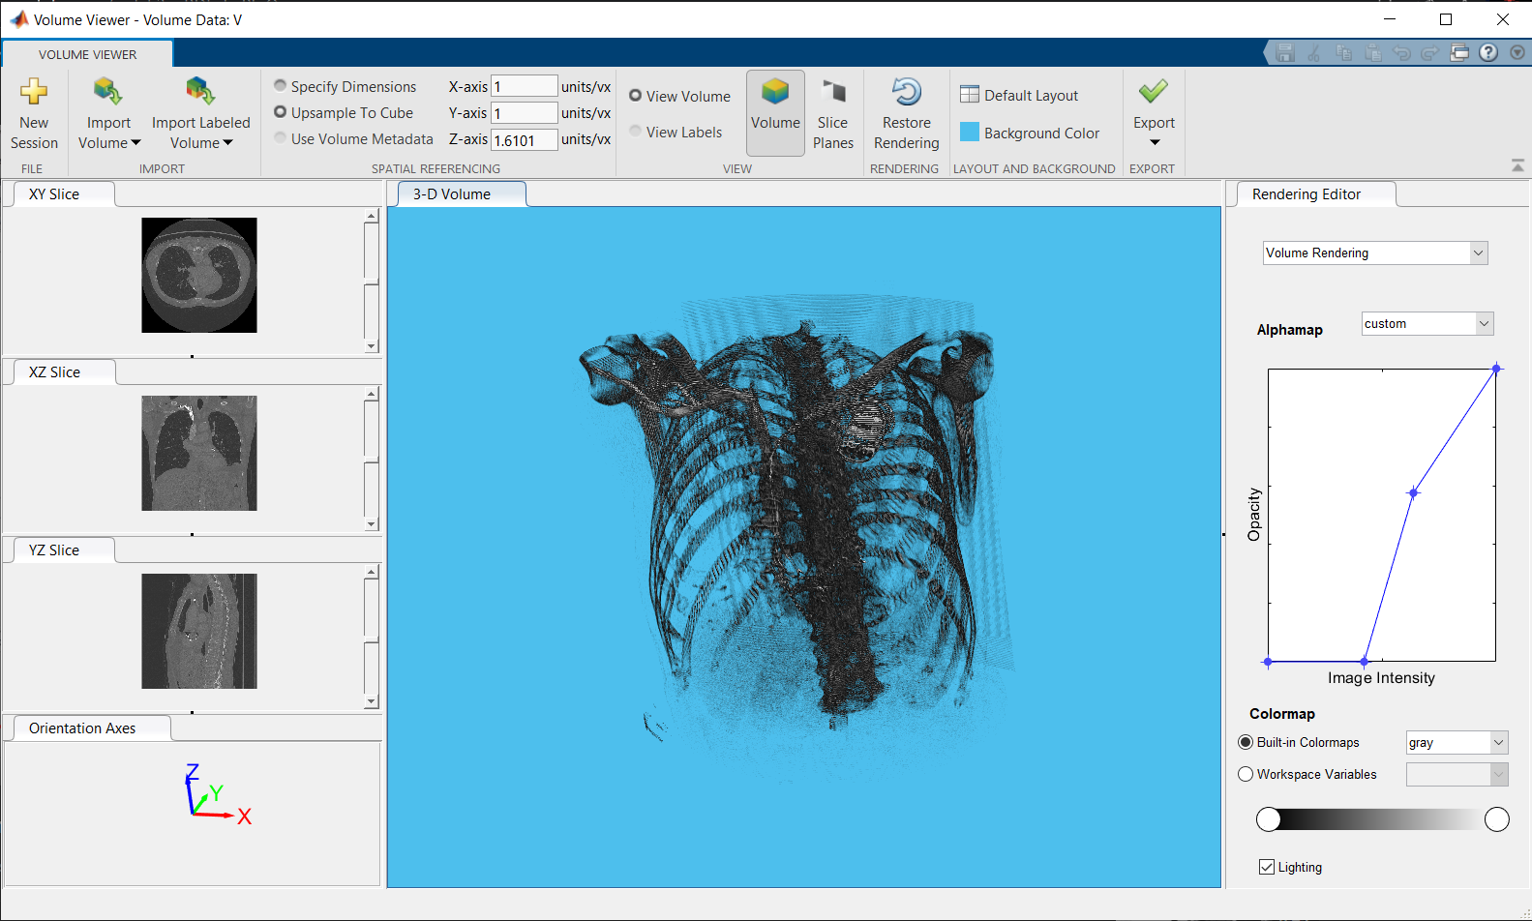

Here, I have altered the image intensity and opacity. To get this rendered output.

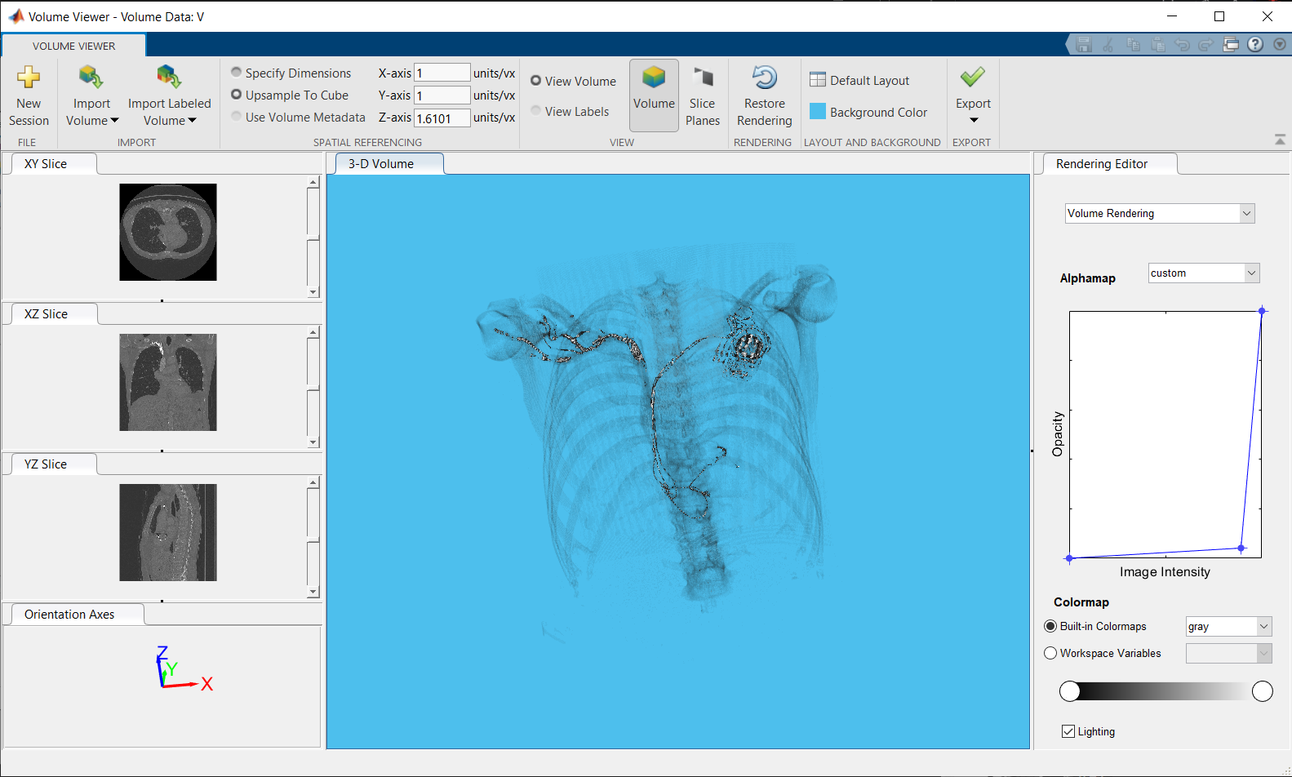

**6.1.5 Volume Rendering with Alpha map: Custom and Color-map: Gray:**

Here, I have altered the image intensity a little more and opacity very little.

**6.1.6 Maximum Intensity Rendering with Alpha map: MRI-MIP and Color-map: Gray:**

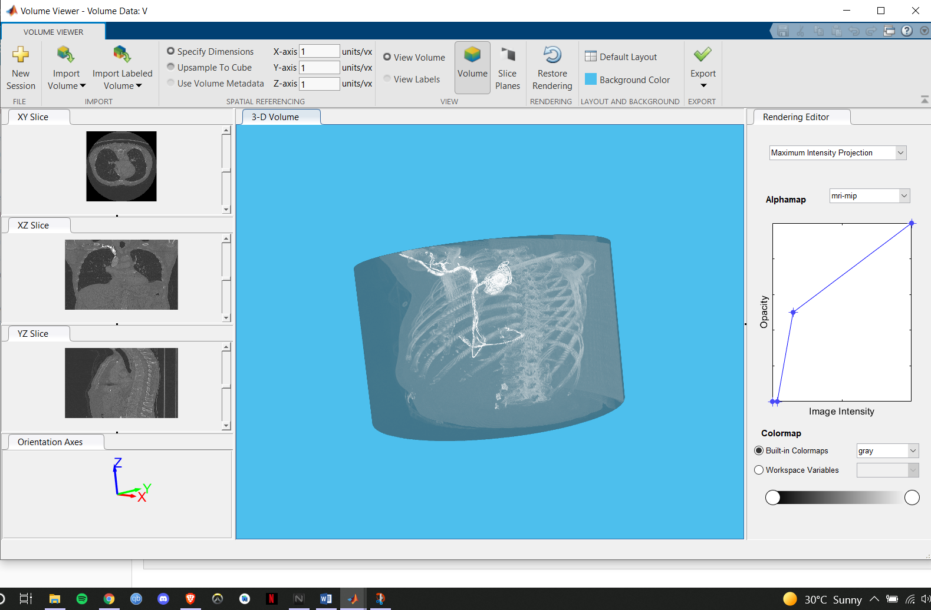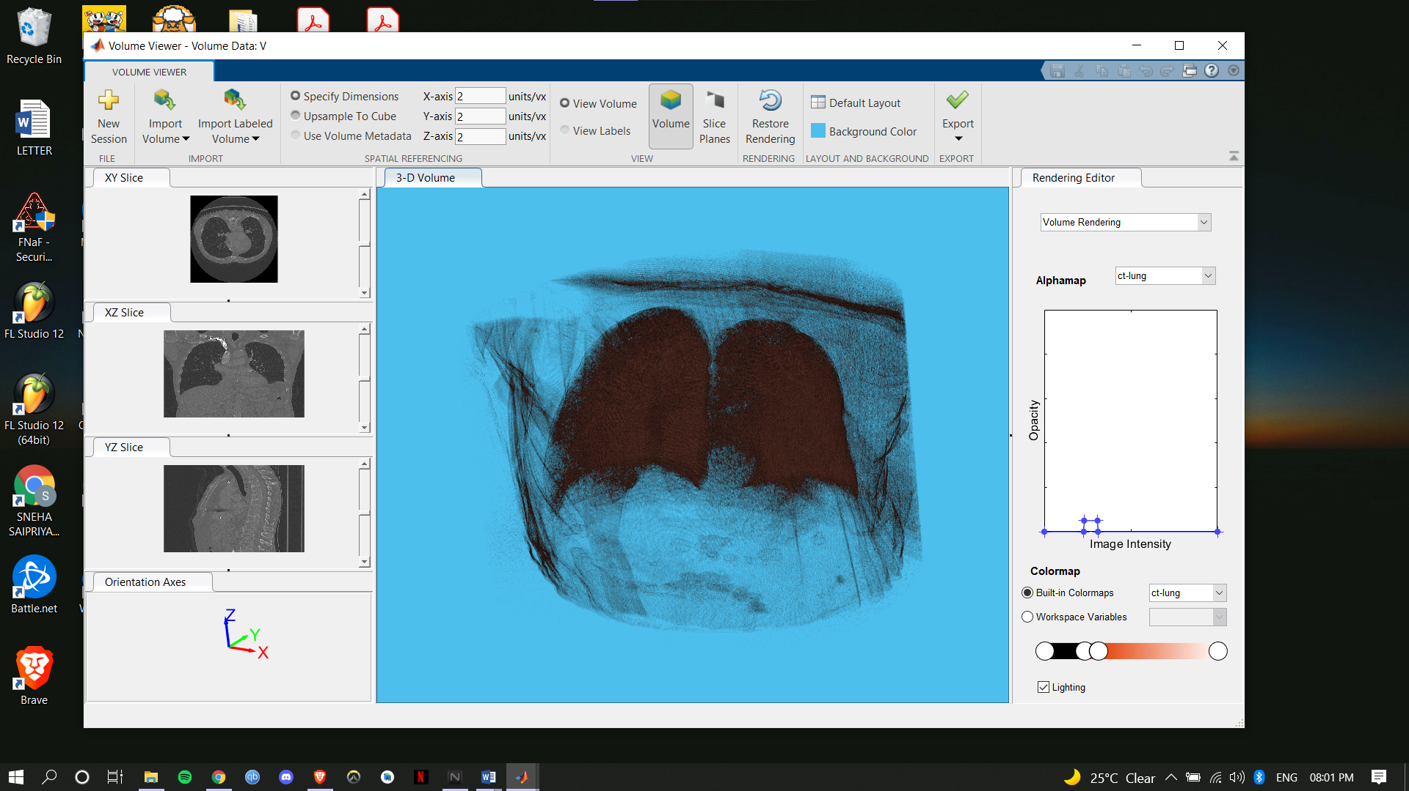

**6.1.7 Volume Rendering with Alpha map: CT- Lung and Color-map: CT-Lung:**

**6.2 Source Code of Three Dimensional Image with Volume Semantic Segmentation:**

>>load(fullfile(toolboxdir('images'),'imdata','BrainMRILabeled','images','vol_001.mat'));

>>volumeSegmenter(vol)

**6.2.1 Segmented Models of Three dimensional MRI using Volume Segmentation:**

Volumetric Semantic Segmentation is also a very useful Tool in MATLAB as we can point out abnormalities in the organs of a body. Here, in my project I have used Volumetric Semantic Segmentation and have identified a tumor in a three dimensional human brain model.

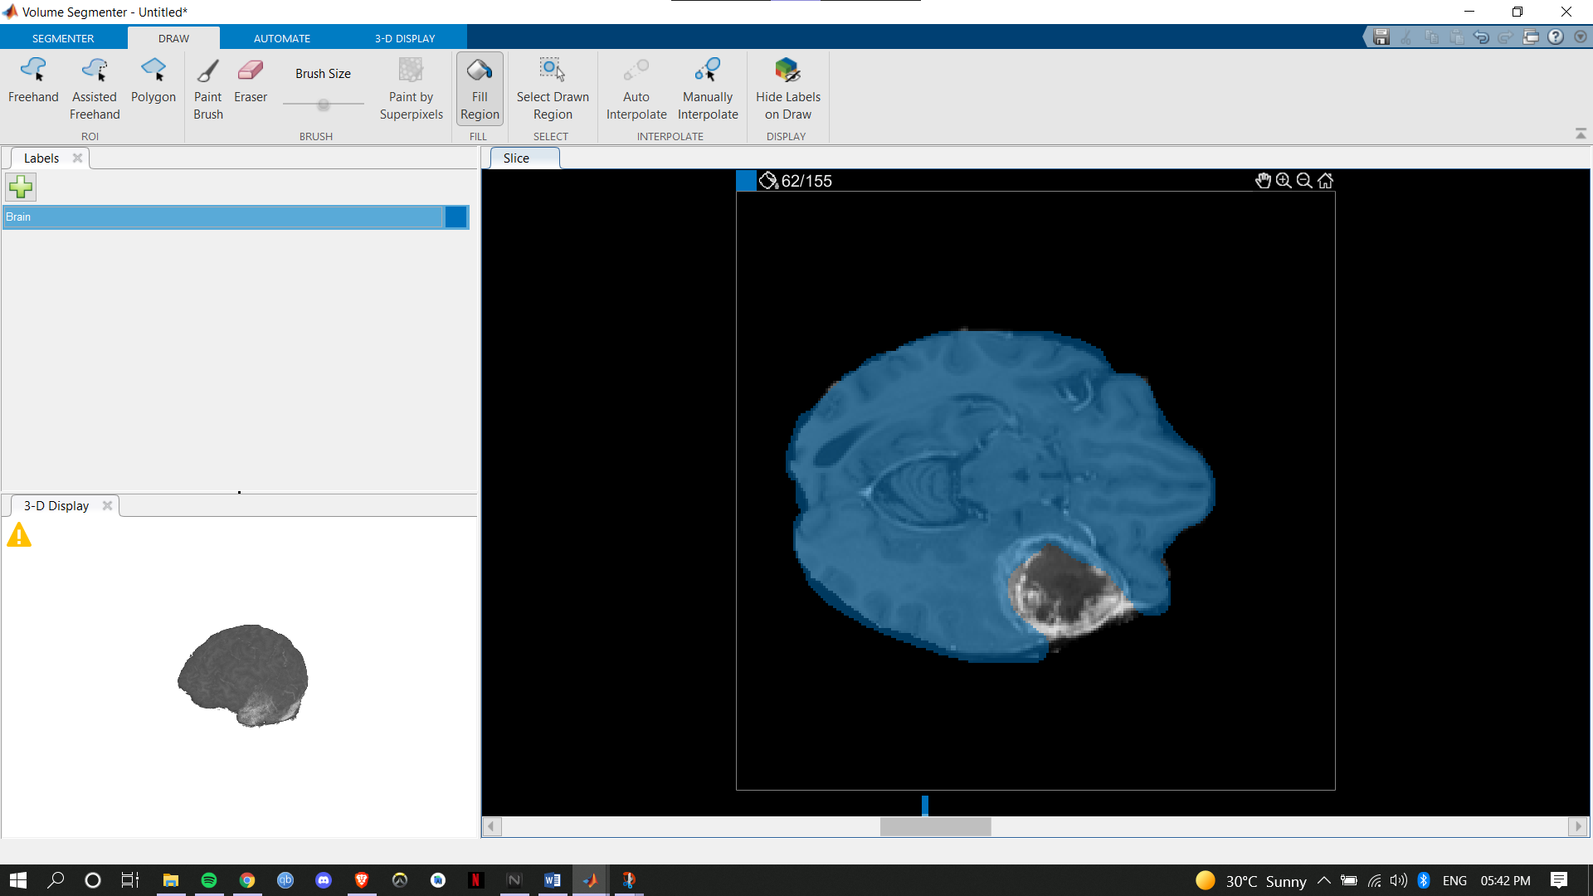

**6.2.2 62/155 Slice Brain Label (First ROI):**

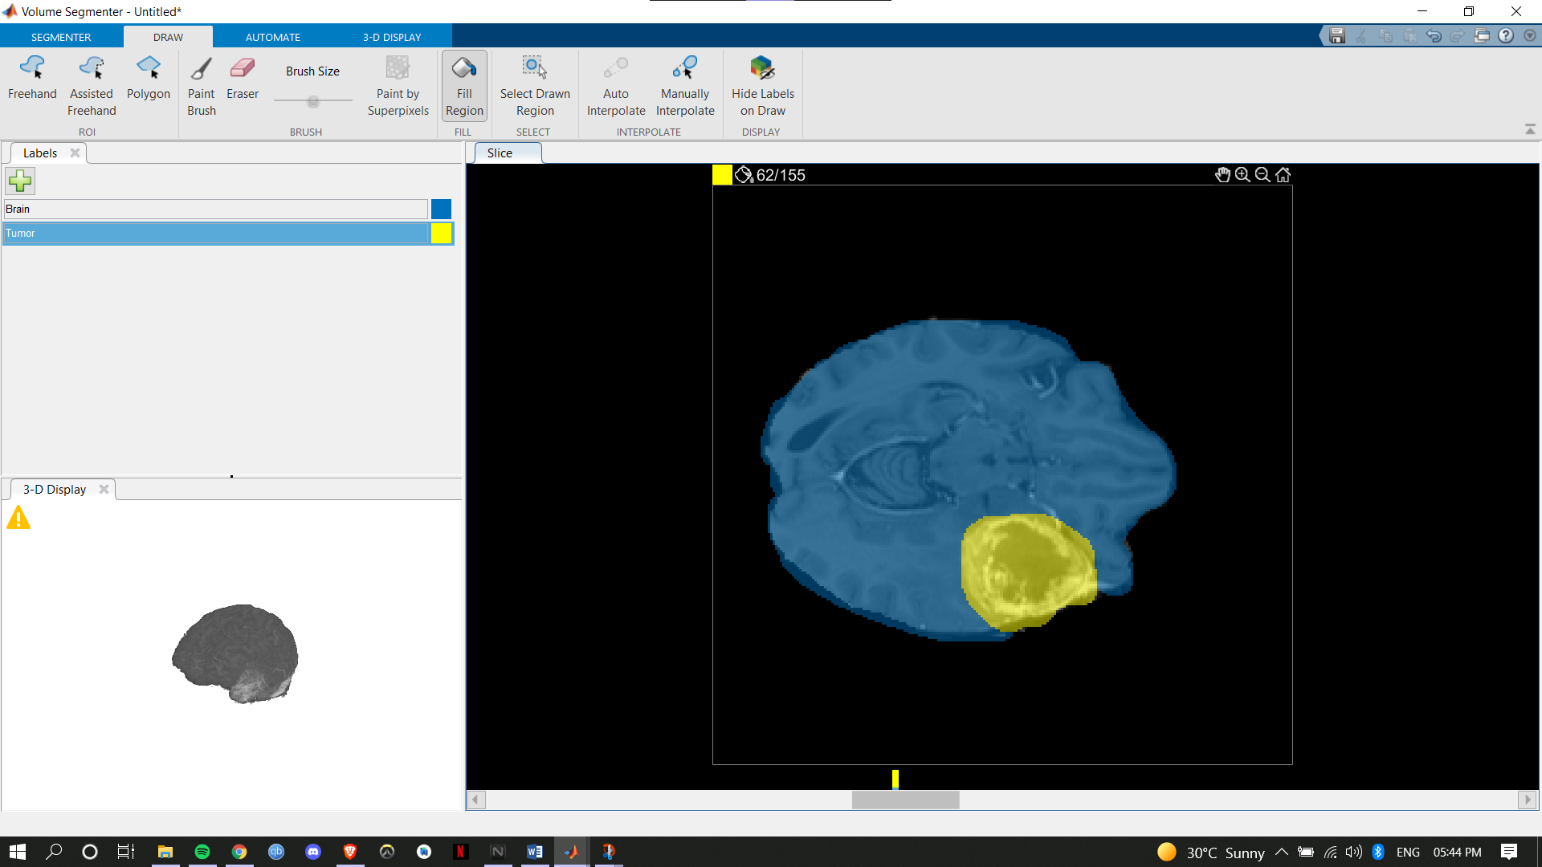

**6.2.3 62/155 Slice Tumor Label (First ROI):**

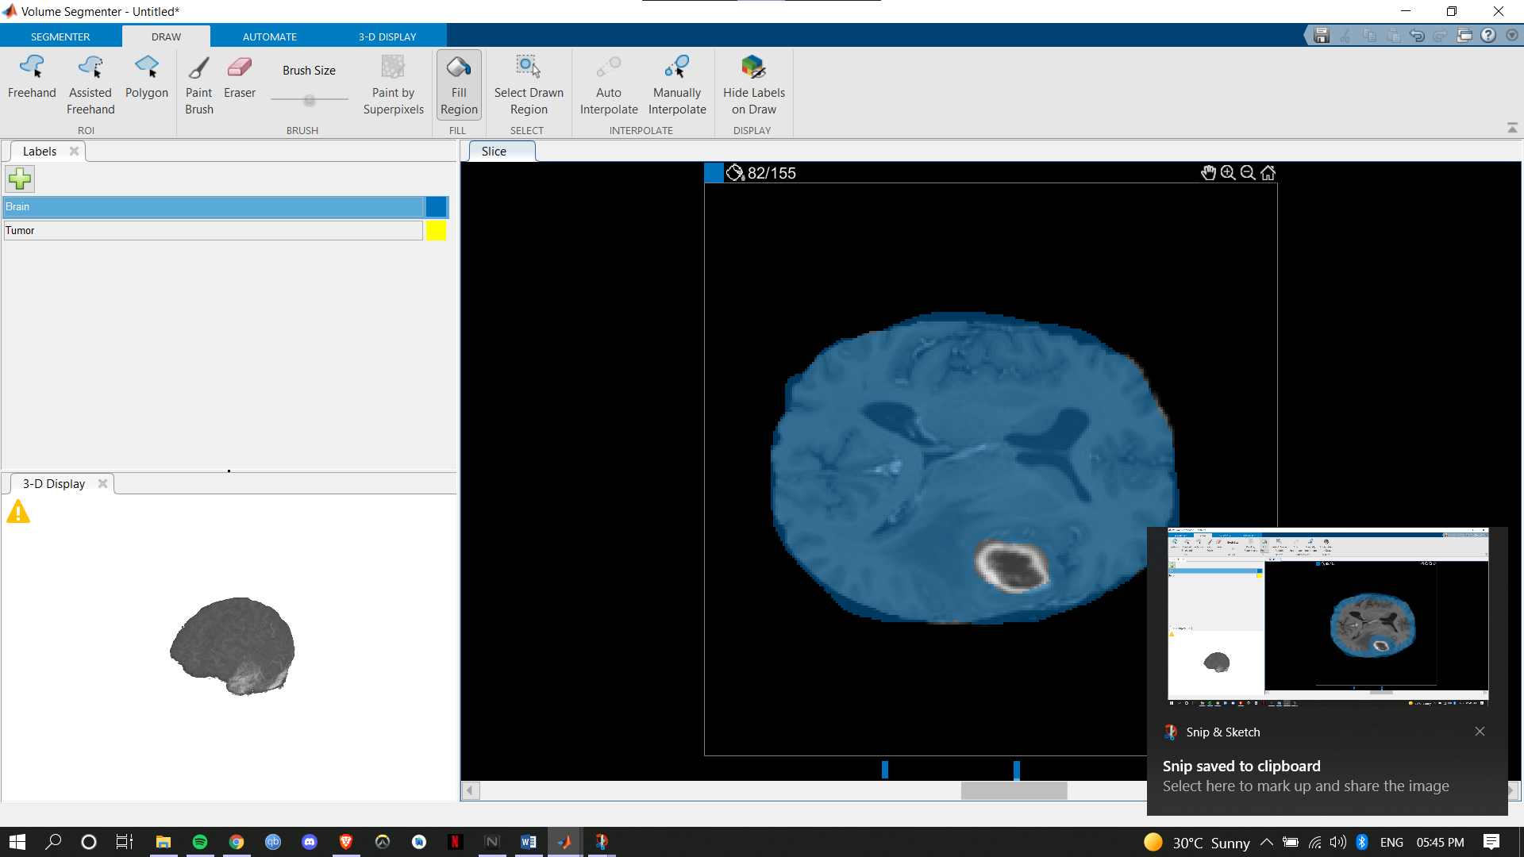

**6.2.4 82/155 Slice Brain Label (Second ROI):**

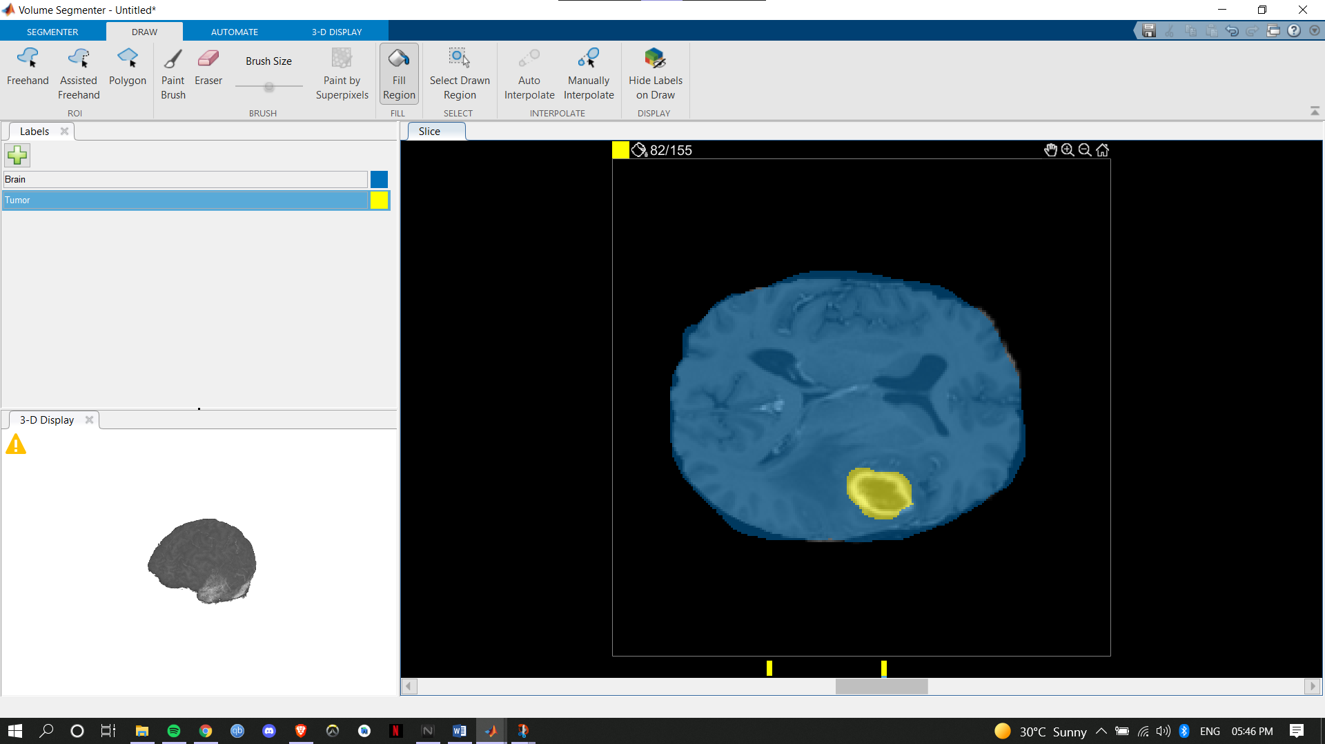

**6.2.5 82/155 Slice Tumor Label (Second ROI):**

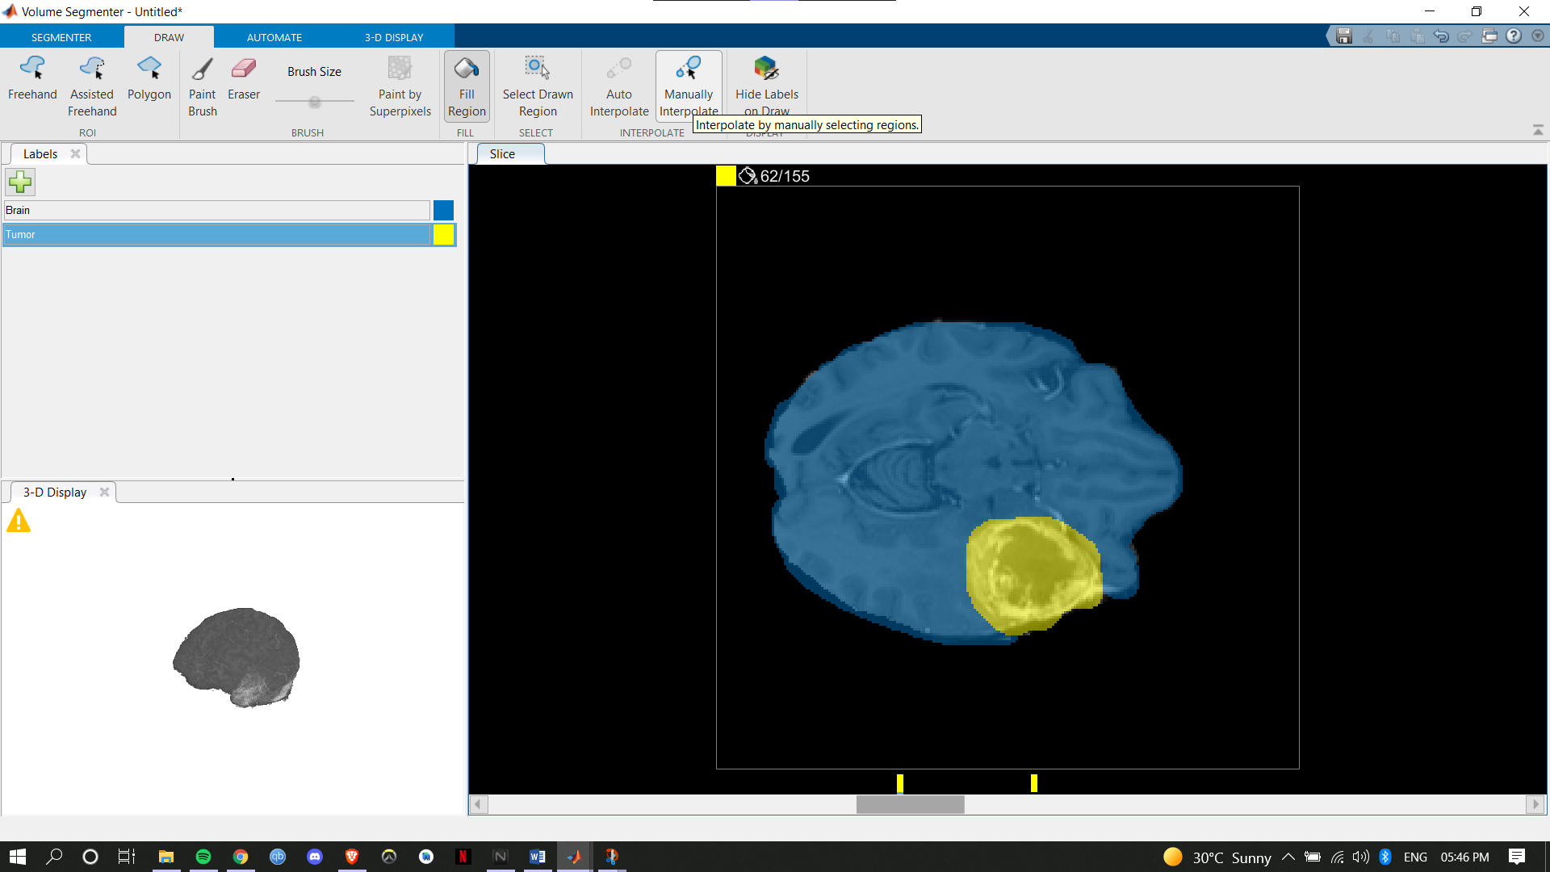

**6.2.6 Before Manual Interpolation of First and Second ROI:**

**6.2.7 After Manual Interpolation of First and Second ROI:**

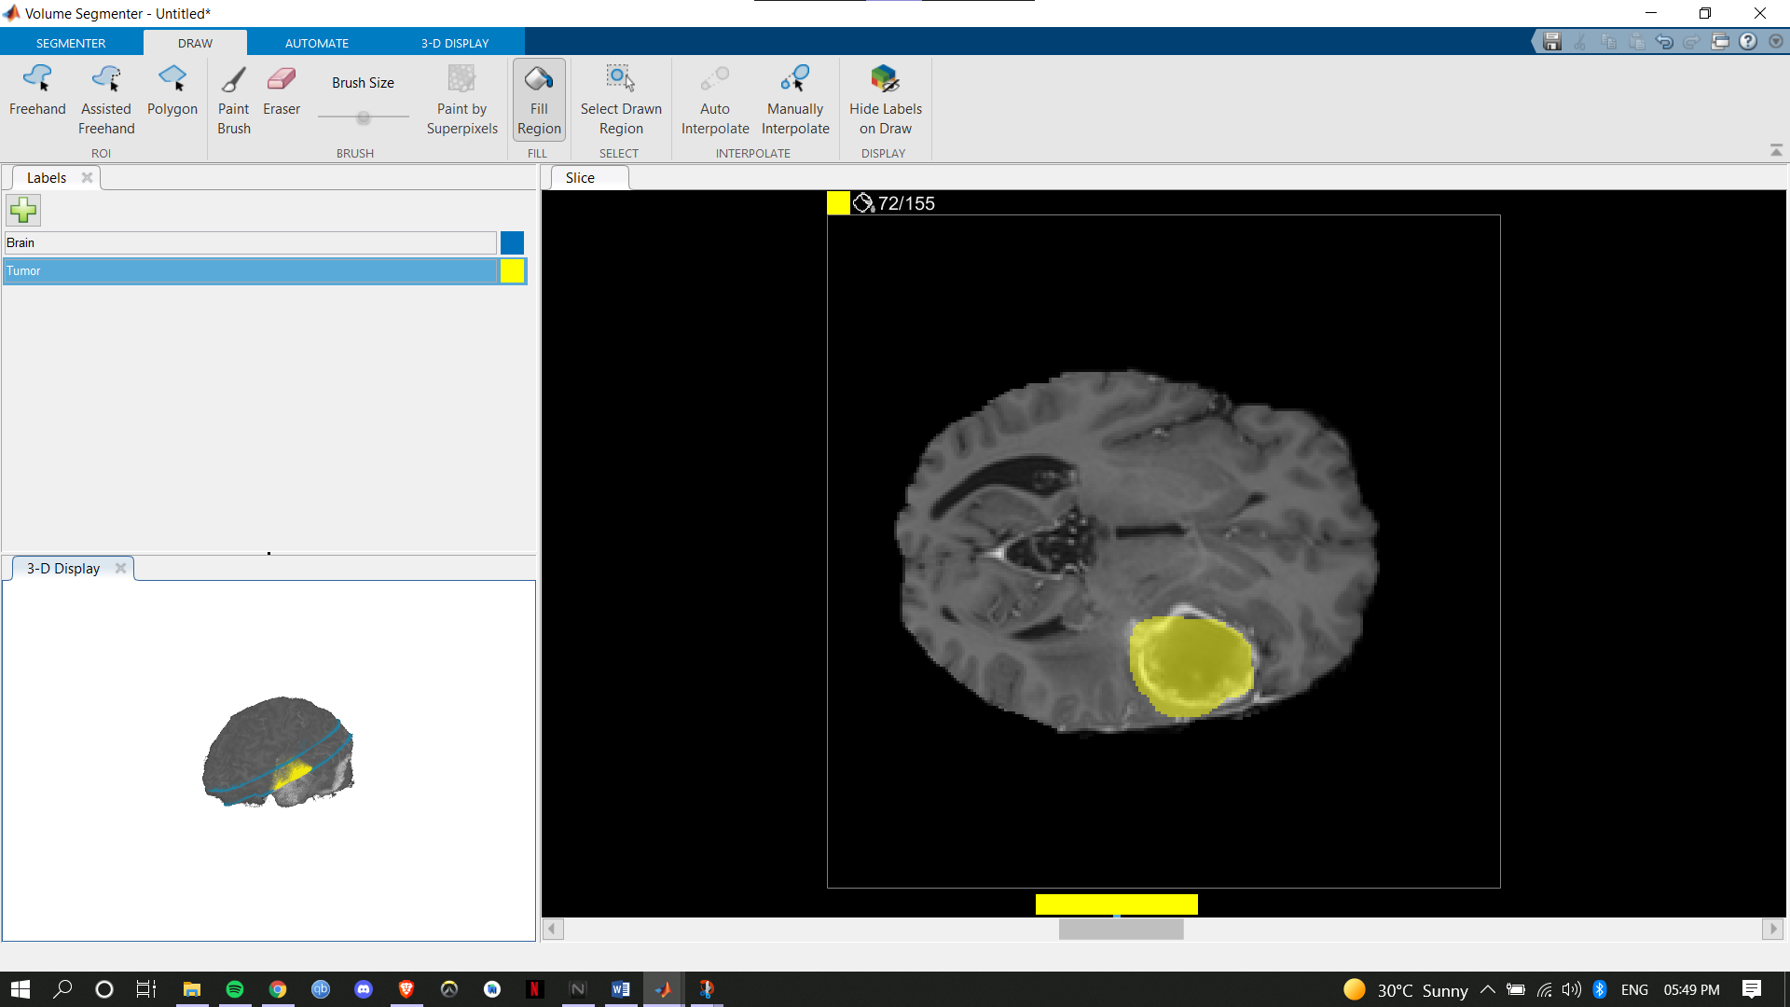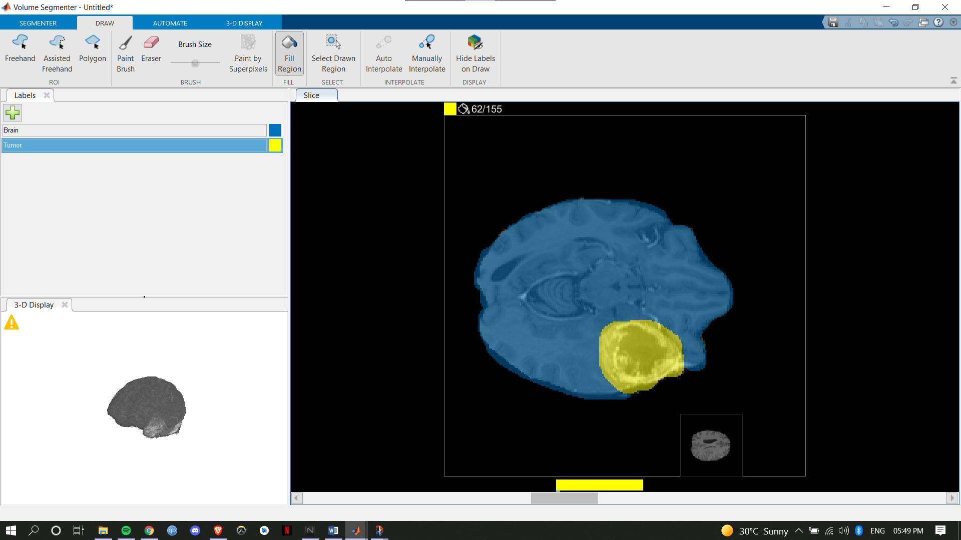

**6.2.8 Slice between Manually Interpolated ROI’s:**

**7. REFERENCES:**

[1] N. Ahmed, T. Natarajan, and K. R. Rao, “Discrete cosine transform,”

IEEE Trans. Comput., vol. C-23, pp. 90–93, Jan. 1974.

[2] R. J. Clark, “Relation between the Karhunen-Loeve and cosine trans-

form,” Proc. IEEE, vol. 128, pp. 359–360, Nov. 1981.

[1] N. Ahmed, T. Natarajan, and K. R. Rao, “Discrete cosine transform,”

IEEE Trans. Comput., vol. C-23, pp. 90–93, Jan. 1974.

[2] R. J. Clark, “Relation between the Karhunen-Loeve and cosine trans-

form,” Proc. IEEE, vol. 128, pp. 359–360, Nov. 1981.

[1] N. Ahmed, T. Natarajan, and K. R. Rao, “Discrete cosine transform,”

IEEE Trans. Comput., vol. C-23, pp. 90–93, Jan. 1974.

[2] R. J. Clark, “Relation between the Karhunen-Loeve and cosine trans-

form,” Proc. IEEE, vol. 128, pp. 359–360, Nov. 1981.

[1] N. Ahmed, T. Natarajan, and K. R. Rao, “Discrete cosine transform,”

IEEE Trans. Comput., vol. C-23, pp. 90–93, Jan. 1974.

[2] R. J. Clark, “Relation between the Karhunen-Loeve and cosine trans-

form,” Proc. IEEE, vol. 128, pp. 359–360, Nov. 1981.

[1] S. K. Dewangan, "Importance & Applications of Digital Image Processing," International Journal of Computer Science & Engineering Technology (IJCSET), vol. 7, no. 7, pp. 316-320, 2016.

[2] D. Zhang, F. Wang, R. Burgos, and D. Boroyevich, "Common mode circulating current control of interleaved three-phase two-level voltage-source converters with discontinuous space-vector modulation," 2009 IEEE Energy Conversion Congress and Exposition, 2009, pp. 2801-2807, doi: 10.1109/ECCE.2009.5316313.

[3] R. S. Kavita, R. Bala, and S. Siwach, "Review paper on overview of image processing and image segmentation, " International journal of Research in Computer applications and Robotics, vol. 1, no. 7, 2013.

[4] H. Zhang, Z. Zhang, and Z. Pei, "Design and Implementation of Image Processing System Based on MATLAB," in International Conference on Logistics Engineering, Management and Computer Science (LEMCS 2015), 2015, pp. 1356-1359, doi: 10.2991/lemcs-15.2015.270.

[5] Image processing system using MATLAB-based analytics research paper

Gerald K. Ijemaru1, Augustine O. Nwajana2, Emmanuel U. Oleka3, Richard I. Otuka4, Isibor K. Ihianle5, Solomon H. Ebenuwa6, Emenike Raymond Obi7

[6] https://en.wikipedia.org/wiki/Discrete_cosine_transform

[7] https://sci-hub.se/10.1109/2945.468390